Unit 4: Exploring Arts Around the World

Lesson 16 : Painting

1. Write the name of each painting object.

Palette brush easel

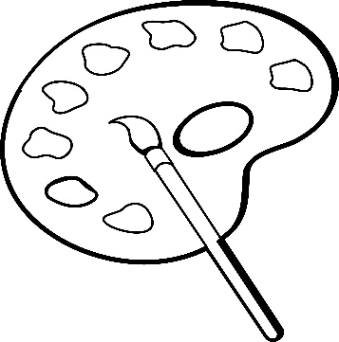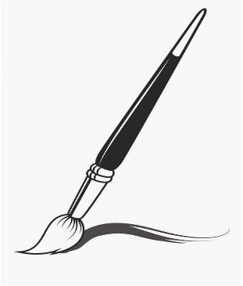

_________________________ ____________________________

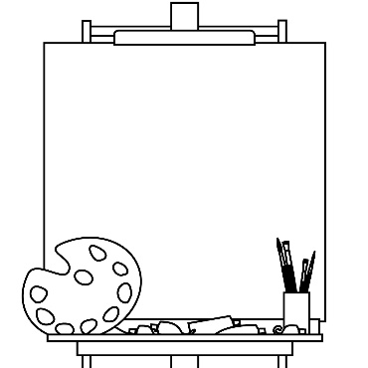

_________________________

1. Write sentences using the words below.

Brush: __________________________________________________________

Palette: __________________________________________________________

Easel:____________________________________________________________

1. Correct the grammatical mistake in each sentence.
2. Sami **draw using** his painting brush .

_______________________________________________________________

1. The birds **flies**  in the sky.

________________________________________________________________

1. My grandfather **read** newspaper while he eats.

_________________________________________________________________

1. My sister **want** to play outside.

_________________________________________________________________

1. Circle the correct form of the verb in each sentence.

The birds ( fly , flies ) high in the sky.

Tomorrow, I’ll ( go , went ) to the mall with my friends.

Aya ( go , goes ) to school every morning.

Maher ( study , studies ) at the college near his home.

Patrick ( fix , fixes ) old cars.

My mother ( work , works ) in a big office .

We ( play , plays ) together in the playground.

Yesterday, Ahmad ( call , called ) his friend.